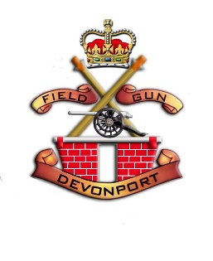

Privacy Policy for Devonport Field Gun Association
Last updated: November 2025
Who we are
Devonport Field Gun Association ("we," "us," or "our") is a registered charity dedicated to preserving the tradition of the Royal Navy Field Gun. Our website address is [your website URL].
Information we collect
We collect personal information you provide when you contact us, sign up for newsletters, make donations, or participate in events. This may include your name, email address, postal address, phone number, and payment details.
How we use your information
We use your data to communicate with you, process donations, manage events, and support our charitable activities. We will never sell your data and only share information when necessary for our charity work, with appropriate safeguards.
Consent and your rights
You have the right to access, correct, or request deletion of your personal data. You may also unsubscribe from communications at any time.
Cookies
Our website uses cookies to improve user experience. You can control or disable cookies in your browser settings.
Data security
We implement security measures to protect your data from unauthorised access or disclosure.
Changes to this policy
We may update this policy occasionally. When significant changes occur, we will notify users by posting on our website.
Contact us
For questions about this policy or your data, please contact us at:
dfgaadmin@icloud.com

