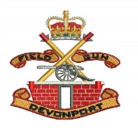
DFGA Social Diary 2026
March 2026
Fri 27th Field Gun Social evening – Venue TBD 1830 – 2359
April 2026
Mon 20th DFGA Committee Meeting - Field Gun Lounge 1000
May 2026
Sat 2nd Army v’s Navy @ Twickenham - Kick off 1400. Sponsor Elwyn Clark (Tickets And Swingers)
Fri 15-17th Northern Field Gun Reunion in Blackpool. Sponsor TG Richardson.
June 2026
Mon 1st Latest date for payments to be made for Tri Command Reunion.
July 2026
Fri 3rd DFGA Annual Reunion Golf at China Fleet Club. 1st Tee at 1015. Sponsor Chris Lewis.
Sat 4th AGM at 1100 – Field Gun Lounge. Social on completion, venue TBD.
Fri 10-11th Tri Command Reunion in Portsmouth. Fri - Ship Anson / Sat – Fratton Park.
Sun 19th Grassy Meadows Charity Shield Memorial Golf at Horsley GC in Derby.
August / September
October
Sat 24th Field Gun Open Day in the park. Static display of FG equipment. Sponsor Nobby Noble.
November
Sun 8th Remembrance Sunday at Devonport Park. Man the drags at 1000.
December
Sat 12th Xmas Social and Buffet – Venue to be confirmed. 1900 – Till Late.
Sat 19th PTI & Field Gun drinks at Union Rooms from 1200.

